**DAILY ONLINE ACTIVITIES SUMMARY**

|  |  |  |  |  |  |  |  |  |
| --- | --- | --- | --- | --- | --- | --- | --- | --- |
| **Date:** | **19/07/2020** | | | | | **Name:** | **Katira Krishna J** | |
| **Sem & Sec** | **8th A** | | | | | **USN:** | **4AL16CS045** | |
| **Online Test Summary** | | | | | | | | |
| **Subject** | | **-** | | | | | | |
| **Max. Marks** | | **-** | | **Score** | | | **-** | |
| **Certification Course Summary** | | | | | | | | |
| **Course** | **Statistics 101** | | | | | | | |
| **Certificate Provider** | | | **Cognitiveclass.ai** | | **Duration** | | | **6 hours** |
| **Coding Challenges** | | | | | | | | |
| **Problem Statement: Python program to implement heap sort** | | | | | | | | |
| **Status: Completed** | | | | | | | | |
| **Uploaded the report in Github** | | | | | **Yes** | | | |
| **If yes Repository name** | | | | | **Krishna_Katira** | | | |
| **Uploaded the report in slack** | | | | | **Yes** | | | |

Online Test Details:

No test conducted

Certification Course Details:

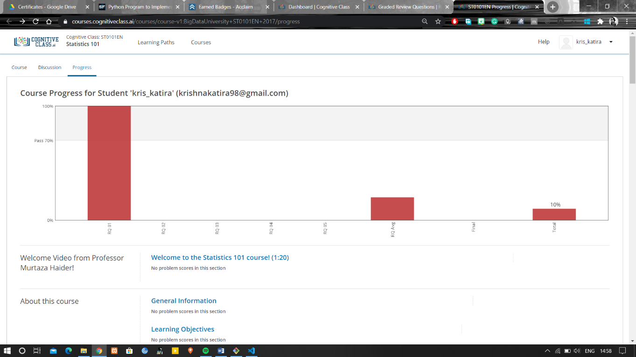

Coding Challenges Details:

**Program:**

def heapsort(alist):

build_max_heap(alist)

for i in range(len(alist) - 1, 0, -1):

alist[0], alist[i] = alist[i], alist[0]

max_heapify(alist, index=0, size=i)

def parent(i):

return (i - 1)//2

def left(i):

return 2*i + 1

def right(i):

return 2*i + 2

def build_max_heap(alist):

length = len(alist)

start = parent(length - 1)

while start >= 0:

max_heapify(alist, index=start, size=length)

start = start - 1

def max_heapify(alist, index, size):

l = left(index)

r = right(index)

if (l < size and alist[l] > alist[index]):

largest = l

else:

largest = index

if (r < size and alist[r] > alist[largest]):

largest = r

if (largest != index):

alist[largest], alist[index] = alist[index], alist[largest]

max_heapify(alist, largest, size)

alist = input('Enter the list of numbers: ').split()

alist = [int(x) for x in alist]

heapsort(alist)

print('Sorted list: ', end='')

print(alist)